Experiment 7 : Sales Analysis - Top Products

Objective : Find the top 5 products by total sales.

Procedure:

Step 1: Prepare Mapper and Reducer
Step 2: Upload Dataset to HDFS
Step 3: Run MapReduce Job
Step 4: View Output
ScreenShot:
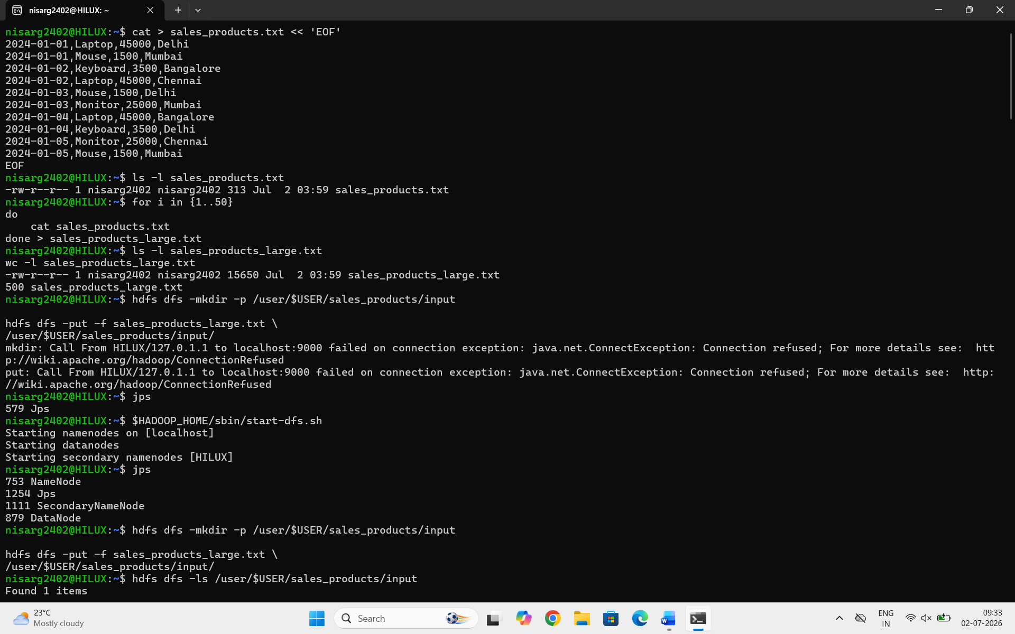
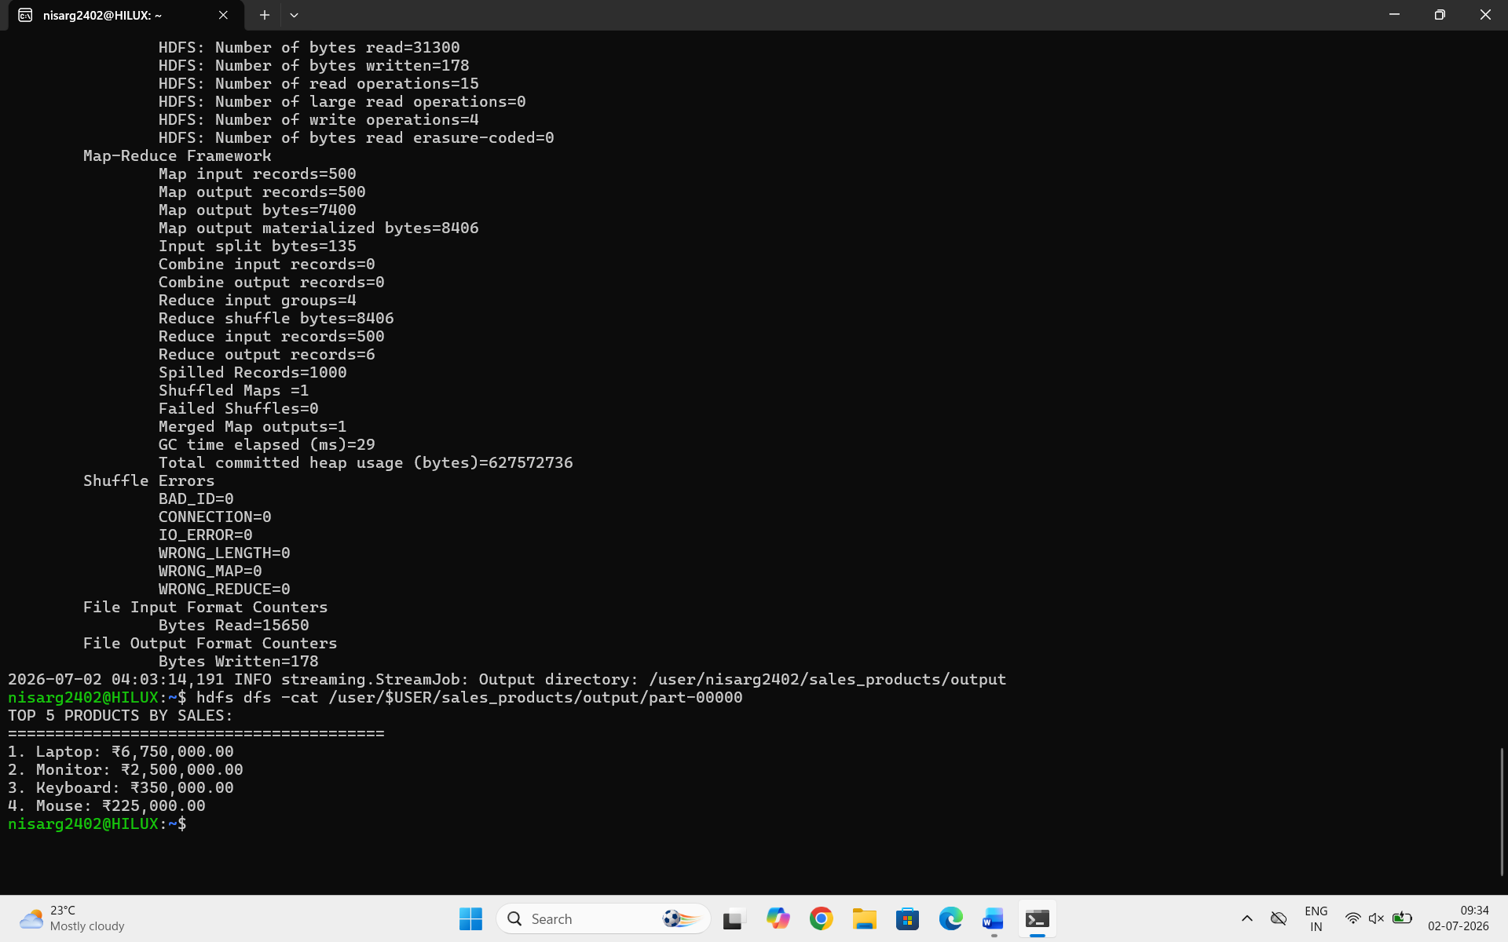

Conclusion
In this experiment, we successfully implemented a City-wise Product Sales Analysis using Hadoop MapReduce.
Key Outcomes:
- Mapper extracted city, product, and price information.
- Reducer aggregated sales per city-product pair.
- Final output identified the top-selling product in each city.
Learning:
- Learned how to use composite keys (city_product) in MapReduce.
- Understood grouping and aggregation in distributed systems.
- Implemented real-world e-commerce analytics use case using Hadoop.

